REPORT

Using visual studio I created a website and then added a new item called web service and named it as weather service.

Also added a new web form as Default.aspx in which I designed a format to get the weather report.

This weather report is shown by entering a zip code in the web page and then submitting it. The report is shown and also the respective city, state, description, weather IDs are shown.

This is the screen shot of how the coding is done

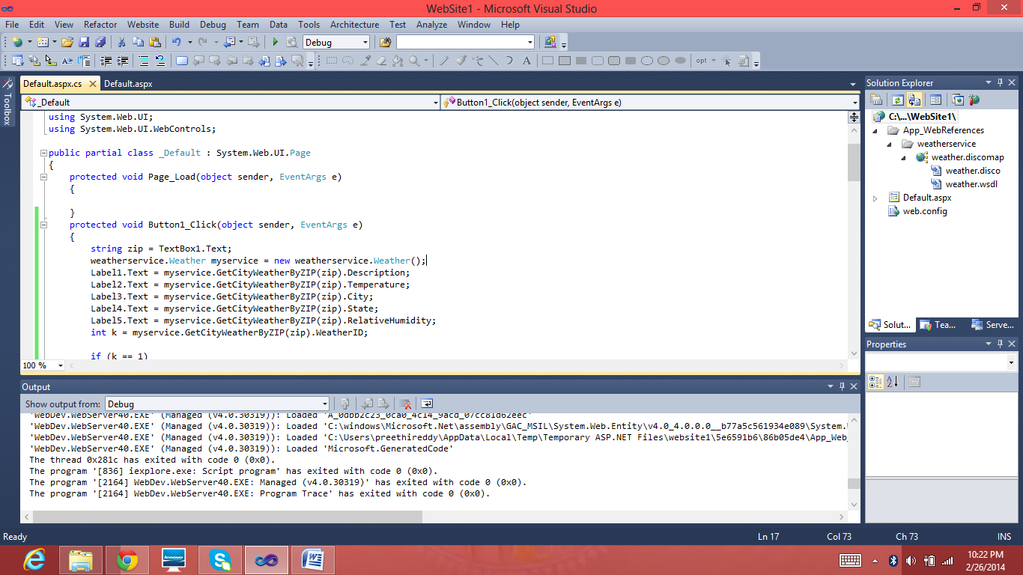

This is how the page looks after debugging the code

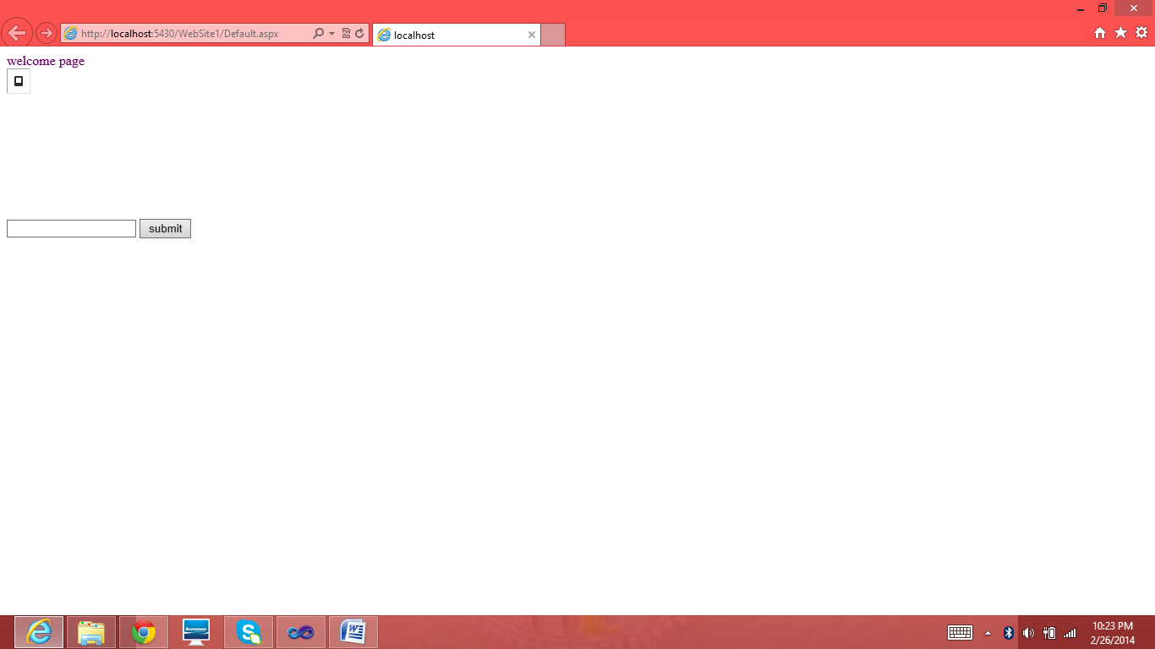

After entering the zip code the following information is shown.

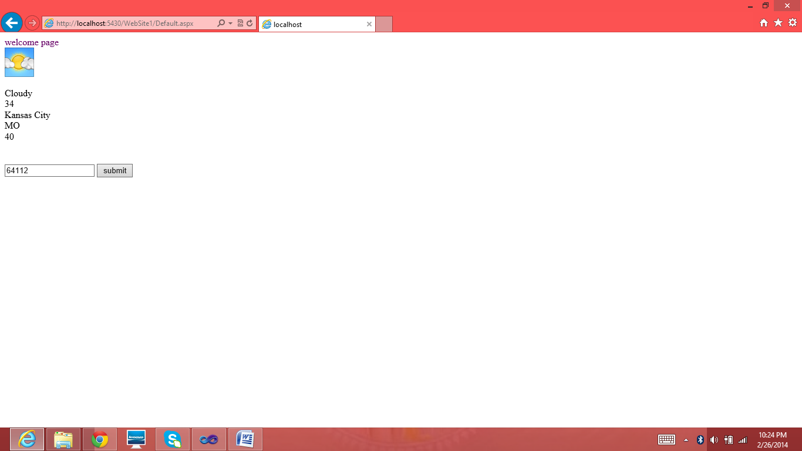

This is another example

